DNA/RNA worksheet KEY

1. What are nucleic acids? Why are they important?

**Nucleic acids are naturally occurring chemical compound that is capable of being broken down to yield phosphoric acid, sugars, and a mixture of organic bases (purines and pyrimidines). They contain information (genetic material) necessary for cellular reproduction. Our ability to function as living organisms is possible because of the many proteins that carry out biological processes. The information needed to synthesize these proteins come from nucleic acids.**

1. What are the two types of nucleic acids, and what are their main differences?

**Ribonucleic acids (RNA) and deoxyribonucleic acid (DNA) are two types of nucleic acids.**

**The differences in structure between DNA and RNA are**

* + **DNA bases are A, G, C, and T; the RNA bases are A, G, C, and U**
  + **the sugar in DNA is 2-deoxy-D-ribose; in RNA it is D-ribose**
  + **DNA is always double stranded; there are several kinds of RNA, all of which are single-stranded**
  + **DNA remains in the nucleus, whereas RNA moves to the cytoplasm of a cell to carry out translation (protein synthesis)**

1. DNA and RNA occur as polymers. What is their monomer called? What are the three components of this monomer and draw the general structure.

**The monomeric units are called nucleotides. The component of a nucleotide consists of D-ribose or 2-deoxy-D-ribose bonded to a purine or pyrimidine base by a β-N-glycosidic bond and phosphoric acid which is esterified with an -OH of the monosaccharide, most commonly on the 5’-OH**

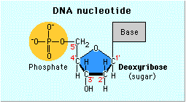

1. Why do you think nucleotides are also sometimes referred to as “bases” or “nucleotide bases”?

**The base contains nitrogen, which are basic since their lone pairs can accept an H+ (Bronsted Lowery Base)**

1. What is the difference between a nucleotide and a nucleoside? Explain by giving an example, using structures.

**A nucleoside is composed of a base attached to a sugar. Once the nucleoside is phosphorylated (on the sugar) a nucleotide is obtained.**

1. Do the following:
2. Name this structure below. **Nucleotide or deoxyadenosine triphosphate**
3. Clearly box and label the nitrogenous base
4. Clearly circle and label the sugar.
5. Label the 5’ and 3’ end of the molecule.
6. Indicate with a star what part of the molecule allows the two strands of DNA to be held together.

Deoxyribose

Adenine

**5’**

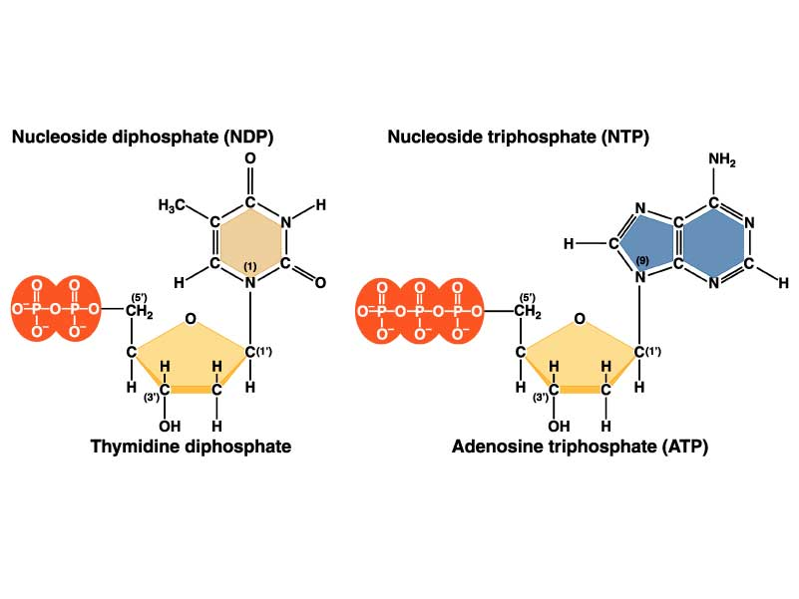

**3’**

Next nucleotide added here

1. What is the name and location of the kind of bond that links a sugar to a phosphate group in the primary structure of nucleic acids (polymerization of nucleotides)?

**3’ to 5’ phosphodiester**

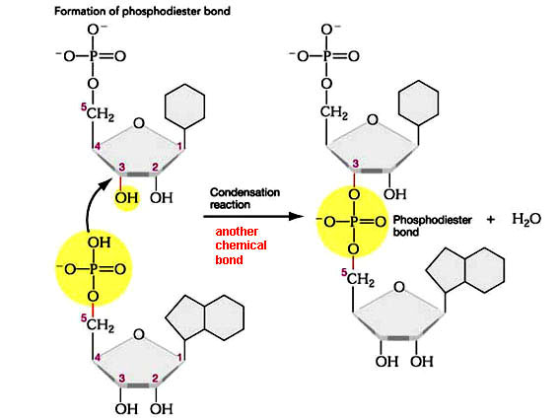

1. What kinds of forces hold the double strands of a DNA double helix together? Do the two strands go in the same direction or in opposite directions?

**Hydrogen bonding between base pairs (G to C: 3 hydrogen-bonds and A to T: 2 Hydrogen bonds) holds the two DNA strand together. A strand in the 5’ to 3’ direction is paired with a strand in the 3’ to 5’ direction.**

1. Three types of RNA involved in comprising the structural and functional core for protein synthesis, serving as a template for translation, and transporting amino acid, Define each type
   * **mRNA- messenger RNA, contains codons that code for amino acids**
   * **tRNA – transfer RNA, brings amino acid to ribosome during translation; has anti-codons that are complementary to mRNA codons**
   * **rRNA – ribosomal RNA, combine with proteins to make ribosomes, the structure that reads codons on the mRNA and assembles amino acids into polypeptides.**
2. What is a codon? What is an anti-codon?

* **Codons are 3 nucleotides of mRNA that code for a specific amino acid**
* **Anti-codons are 3 nucleotides of tRNA that are complementary to a codon on the mRNA**

1. What codon(s) signal the start and stop of protein synthesis?

* **Start codon (typically AUG)**
* **Stop codon (UAA, UAG, or UGA)**

1. What are introns and exons?

* **Introns- sequences of mRNA that do not contain the code for protein**
* **Exons- sequences of mRNA that contain the code for protein**

1. Define transcription and translation. Which process occurs first in order to make protein from DNA?

Transcription takes place first. DNA is used to make mRNA, which can leave the nucleus

**The steps of transcription are initiation, elongation of the mRNA molecule, and termination. During initiation, enzymes unzip the DNA and RNA polymerase binds. During elongation, RNA polymerase “reads” the DNA strand and adds complementary nucleotides to the growing RNA strand. During termination, synthesis of the RNA molecule ends and the DNA molecule reforms. Remember the mRNA will only contain exons (expressing sequences) the introns have been removed.**

**Translation occurs second where the sequence from mRNA, dictates the amino acid of proteins. When tRNA brings amino acids to the ribosome, peptides are formed thus producing a protein**

**The steps of translation are initiation (ribosomal subunit binds to initiator codon), elongation of the polypeptide, and termination (release of the last tRNA from the ribosome, signified by a stop codon).**

1. In one sentence, explain what tRNA does.

**A tRNA will “translate” the codons (in mRNA), by matching with the correct anticodons, into specific amino acids**

1. What is the mRNA, and what is the amino acid sequence for the following DNA strand?

TACCAGGCTGTTACT

**The codons in the RNA are AUG, GUC, CGA, CAA & UGA.**

**This gives an amino acid sequence of – Start (Met)-Valine -Arginine -Glutamine -Stop.**

1. The following is a single strand of DNA: **3’** **TACACACAAACGGGG 5’**. Write the following in the space provided.

1. Complementary DNA strand:

**5’ ATG TGT GTT TGC CCC 3’**

1. mRNA: (**transcribe the gene in bold letters**)

**5’ AUG UGU GUU UGC CCC 3’**

1. amino acid sequence:

**methionine, cysteine, valine, cysteine, proline**